**Jenkins Installation on Linux server**

**Oracle Linux Server release 3.10.0-514.10.2.el7.x86_64**

**Jenkins 2.192**

**IP Address: 10.52.210.207**

**Installation Starts here**

export https_proxy=https://147.149.2.71:8080

export http_proxy=http://147.149.2.71:8080

[cdadmin@bld02164007 ~]$ **cp jenkins.zip /appl_workspace/Jenkins**

[cdadmin@bld02164007 Jenkins]$ **unzip jenkins.zip**

Download latest **.war** file as per installed Jenkins version with below command in the same directory.

[cdadmin@bld02164007 Jenkins]$ **wget** [**http://updates.jenkins-ci.org/download/war/2.192.1/jenkins.war**](http://updates.jenkins-ci.org/download/war/2.192.1/jenkins.war)

Configure your .sh file to initialized Jenkins services –

[cdadmin@bld02164007 Jenkins]$ **vi startJenkins.sh**

# Daemonize jenkins

echo -n "Starting jenkins service"

ORACLE_HOME=/oraclient/product/12.2.0.1.0/client/

export ORACLE_HOME

MAVEN_HOME=/appl_workspace/Maven/apache-maven-3.6.1

export MAVEN_HOME

JAVA_HOME=/usr

export JAVA_HOME

JENKINS_HOME=/appl_workspace/Jenkins

export JENKINS_HOME

export HTTP_PORT=61112

export HTTP_HOST=10.52.210.207

export LOGFILE=/appl_workspace/Jenkins/logs/jenkin.logs

export PATH=$PATH:$ORACLE_HOME/OPatch:$MAVEN_HOME/bin:$JAVA_HOME/bin:$JENKINS_HOME

$JAVA_HOME/bin/java -jar jenkins.war --httpPort=$HTTP_PORT --httpListenAddress=$HTTP_HOST --prefix=/lode </dev/null >>$LOGFILE 2>&1 &

Once configured above script. Then execute and check for logs

[cdadmin@bld02164007 Jenkins]$ **nohup ./ startJenkins.sh &**

Check logs –

[cdadmin@bld02164007 logs]$ **tail -100f jenkin.logs**

Once you received Jenkins services fully up and running then try to log in Jenkins from browser.

<http://10.52.210.207:61112/lode>

[cdadmin@bld02164007 Jenkins]$ **netstat –ntpl**

(Not all processes could be identified, non-owned process info

will not be shown, you would have to be root to see it all.)

Active Internet connections (only servers)

Proto Recv-Q Send-Q Local Address Foreign Address State PID/Program name

tcp 0 0 0.0.0.0:111 0.0.0.0:* LISTEN -

tcp 0 0 0.0.0.0:80 0.0.0.0:* LISTEN -

tcp 0 0 0.0.0.0:8080 0.0.0.0:* LISTEN 17417/java

tcp 0 0 10.52.210.207:22 0.0.0.0:* LISTEN -

tcp 0 0 **10.52.210.207:61112** 0.0.0.0:* LISTEN 10991/java

tcp 0 0 0.0.0.0:38084 0.0.0.0:* LISTEN 10991/java

tcp 0 0 127.0.0.1:8005 0.0.0.0:* LISTEN 17417/java

tcp 0 0 0.0.0.0:8009 0.0.0.0:* LISTEN 17417/java

tcp6 0 0 :::111 :::* LISTEN -

tcp6 0 0 :::7738 :::* LISTEN -

To find out the Jenkins process ID -

[cdadmin@bld02164007 Jenkins]$ **ps -ef |grep Jenkins**

cdadmin 10991 1 0 Aug30 ? 00:23:39 /usr/bin/java -jar jenkins.war --httpPort=61112 --httpListenAddress=10.52.210.207 --prefix=/lode

cdadmin 28869 25662 0 07:44 pts/1 00:00:00 grep --color=auto Jenkins

[cdadmin@bld02164007 ~]$ kill -9 10991

**Note** – You can download the required plugins from Jenkins browser under Manage Jenkins option. Also check version compatibility with Jenkins while integrating because due to incompatibility sometimes tools not working properly.

**From Manage Jenkins window –**

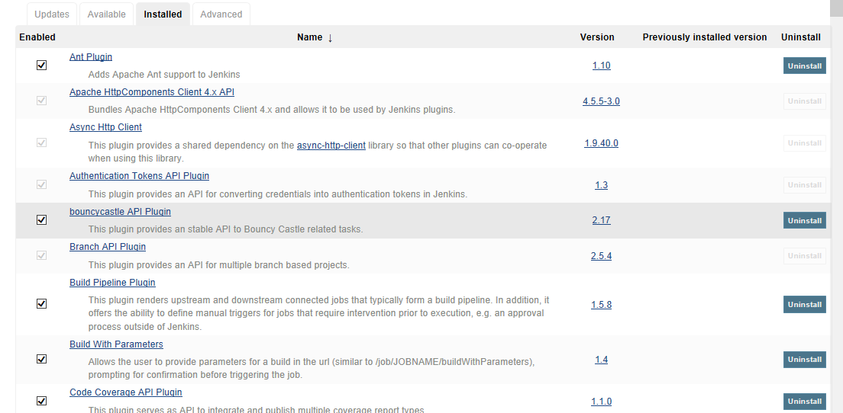

If other systems are integrated with Jenkins then we need to set up configuration in Jenkins under Manage Jenkins – e.g.

**From Configuration System –**

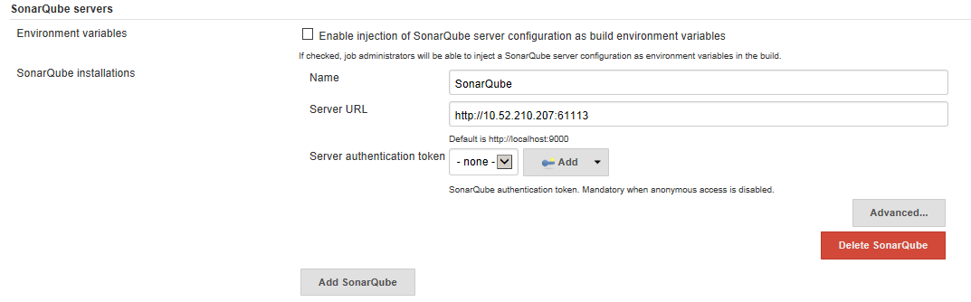

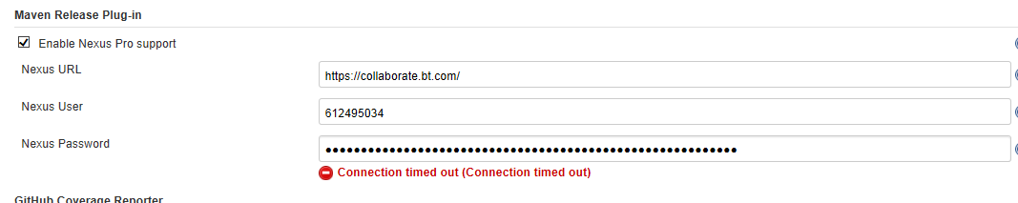

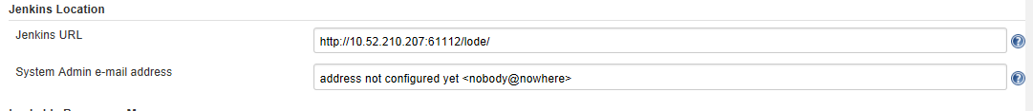

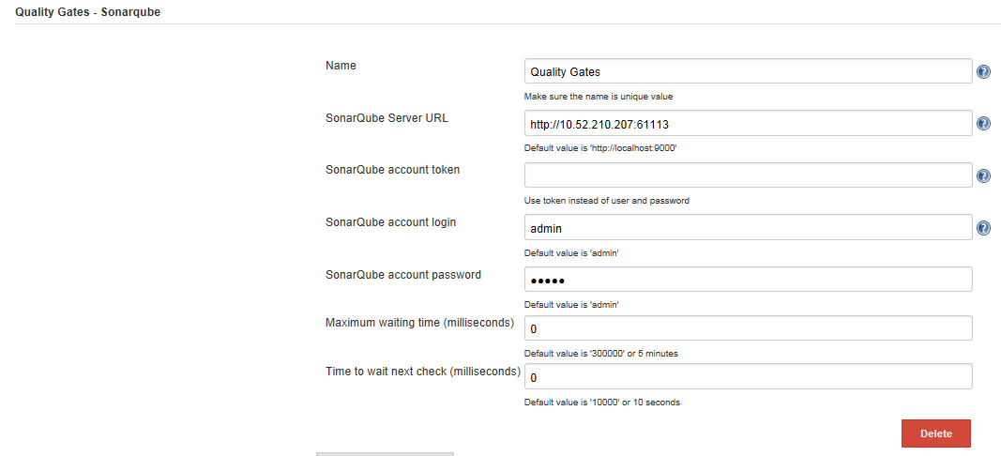

**From Global tool configuration settings –**

